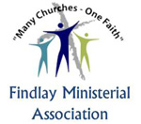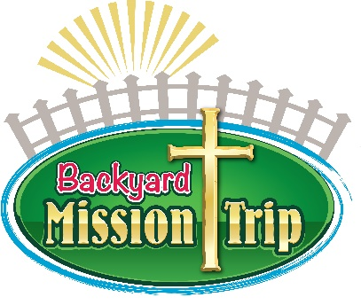
VOLUNTEER
WAIVER OF LIABILITY

This Release and Waiver of Liability (the “Release”) executed: DATE: , 20 in favor of Findlay Ministerial Association, Backyard Mission Trip, or any affiliated congregation and its respective directors, officers, trustees, employees, volunteers and agents (collectively, the “Released Parties”). I, the Volunteer, desire to work as a volunteer for one or more of the Released Parties and engage in the activities related to being a volunteer ("Activities"). The Volunteer understands that the activities may include constructing and rehabilitating residential buildings, landscaping, and consuming food.

The Volunteer hereby freely, voluntarily, and without duress executes this Release under the following terms:
Waiver and Release. I, the Volunteer, do hereby release and forever discharge and hold harmless the Released Parties and their successors and assigns from any and all liability, claims and demands which I or my heirs, assigns, next of kin or legal representatives may have or which may hereinafter accrue with respect to any bodily injury, personal injury, illness, death or property damage which arise or may hereafter arise from or is in any way related to my Activities with any of the Released Parties, whether caused wholly or in part by the simple negligence, fault or other misconduct, other than intentional or grossly negligent conduct, of any of the Released Parties or of other volunteers. I understand and acknowledge that by this Release I knowingly assume the risk of injury, harm and loss associated with the Activities. I also understand that the Released Parties do not assume any responsibility for or obligation to provide financial assistance or other assistance, including but not limited to medical, health or disability insurance in the event of injury, illness, death or property damage.
Medical Treatment. I, the Volunteer, do hereby release and forever discharge the Released Parties from any claim or action whatsoever which arises or may hereafter arise on account of any first aid, treatment or service rendered in connection with my Activities with any of the Released Parties.
Assumption of the Risk. I, the Volunteer, understand that my Activities may include work that may be hazardous to me, including, but not limited to, the following: construction; loading and unloading; travel to and from the work sites; and exposure to lead, asbestos, and mold, which may cause or worsen certain illnesses, especially if I do not wear protective equipment, am exposed for extended periods of time, or have a pre-existing immune system deficiency. I also understand there is some inherent risk in consuming foods. I further understand insurrection, criminal activities, inclement weather or other circumstances that could threaten my health or safety.
Insurance. I, the Volunteer, understand that, except as otherwise agreed to by the Released Parties in writing, the Released Parties are under no obligation to provide, carry or maintain health, medical, travel, disability or other insurance coverage for any Volunteer. Each Volunteer is expected and encouraged to obtain his or her own health, medical, travel, disability or other insurance coverage.
Photographic Release. Volunteer does hereby grant and convey unto Findlay Ministerial Association all right, title and interest in any and all photographic images and video or audio recordings made by Findlay Ministerial Association during the Backyard Mission Trip, including, but not limited to, any royalties, proceeds, or other benefits derived from such photographs or recordings.
Other. Volunteer expressly agrees that this Release is intended to be as broad and inclusive as permitted by the laws of the States of Ohio, and that this Release shall be governed by and interpreted in accordance with the laws of the State of Ohio. Volunteer agrees that in the event that any clause of this Release shall be held to be invalid by any court of competent jurisdiction, the invalidity of such clause or provision shall not otherwise affect the remaining provisions of this Release which shall continue to be enforceable.

IN WITNESS WHEREOF, Volunteer has executed this Release as of the day and year first above written.

Volunteer Name: PLEASE PRINT:
VOLUNTEER IS A MINOR CHILD? (17 years of age or under) YES NO

Signature of Volunteer, if volunteer is Minor Child, Please have Parent or Legal Guardian Sign Below:
X: Volunteer or Parent/Guardian

Volunteer Address (please print):
Street City State Zip

Day Phone Number: Email:

Emergency Contact Name:______________________________________

Work Phone: (______)________________ Home Phone: (_______)________________

